**Database Iteration 2 Plan**

On this iteration I want to work on creating more queries that will be useful for the workers and the patients. The main queries I want to add are queries that show the information of different roles, Queries that have a list of workers and patients, how many people of different roles. This will help them get knowledge of the company and make it easier to see if information on staff and patients are correct or need to be updated. Because of this I will also need to update the roles to fit the new queries. Adding Addresses to the Patient table split up into groups (Postcode, Address, City).

**Queries I want to add:**

**-Role’s information:** Have a place that shows all Worker’s information, Patient information and contactors information

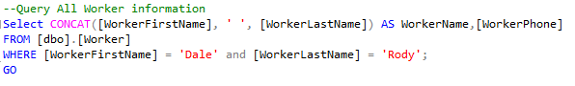

**-List of Roles:** List of all workers, patients, and contactors

**-Count of Roles:** Have queries that say how many workers, patients, and contactors in total

-**Patient’s Carer:** who cares for a patient



-**Patient’s Location:** Be able to view a patient's location

**To do next iteration:**

In the final iteration I want to focus on security and adding more testing to the database.

* Make sure queries don’t information that can be viewed by people that should not have access to the information.
* Add Security by Hashing important information and making sure passwords are safe.
* Be in Unicode datatype.
* Add more workers and patients to the database to test rules on names and datatypes.
* Previously I missed on the contact table how they were contacted.
* Fix data types in the table have noticed a lot of them that need to be formatted differently. (Phone datatype)